Required resources:
- Source : ADLS Gen2
- ETL/ELT PipeLine : Auto Loader
- Destination : Databricks Unity Catalog Delta Tables
- Transformations : azure data bricks- Pyspark
- app registration
- key vaults

Architecture diagram:
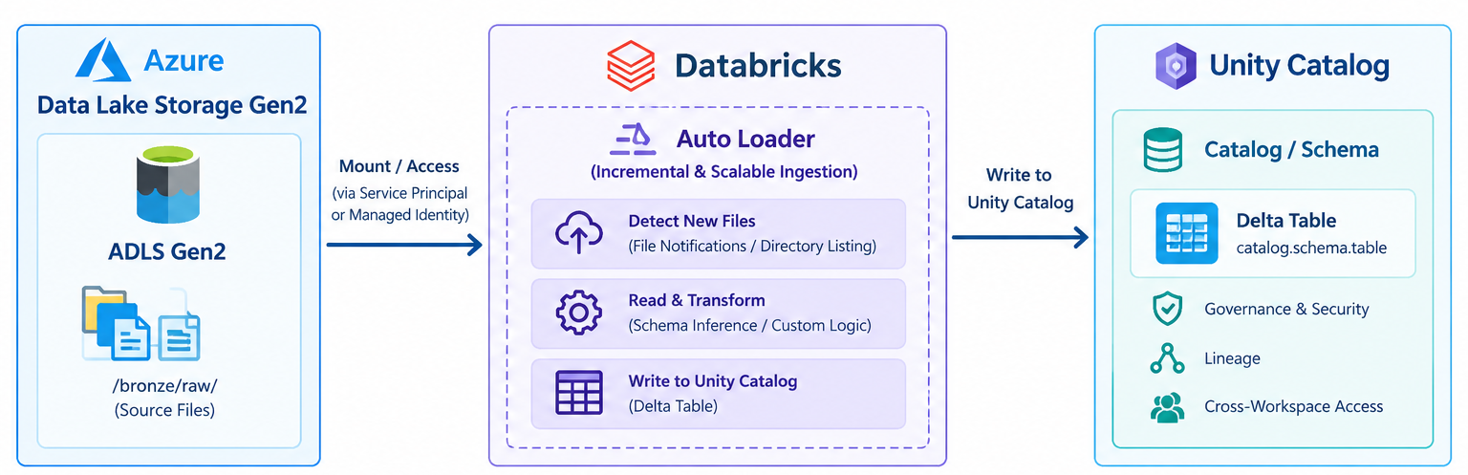

Phase 1: Azure Infrastructure Setup

Step 1.1: Create Resource Group
GUI Steps:
- Go to Azure Portal
- Click "Create a resource" → Search "Resource group"
- Fill in:
  - Subscription: Our subscription detail
  - Resource group name: rg-Banking-project01
  - Region: Central India
- Click "Review + create" → "Create"

Step 1.2: Create Storage Account (ADLS Gen2)
- Click "Create a resource" → Search "Storage account"
- Fill in:
  - Subscription: Our subscription detail
  - Resource group: Rg-Banking-project01
  - Storage account name: bankingstorageprojecto1
  - Region: Central India
  - Performance: Standard
  - Redundancy: Locally-redundant storage (LRS)
- Click "Advanced" tab:
  - Enable hierarchical namespace: Checked ✓
- Click "Review + create" → "Create"

Step 1.3: Create Containers
GUI Steps:
- Go to your storage account →Data Storage - > "Containers" (left menu)
- Click "+ Container" for each:
  - Name: bronze → Public access level: Private → Create

Uploading data into container
- Go to storage account bankingstorageprojecto1
- Click "Containers" → Click "bronze"
- Click "Upload" → "Browse for files"
- Select all 1 CSV files:
  - Accounts.csv
- Click "Upload"

Step 1.4: Create Databricks Workspace
GUI Steps:
- Click "Create a resource" → Search "Azure Databricks"
- Fill in:
  - Workspace name: db-banking-project01
  - Resource group: Rg-Banking-project01
  - Location: Central India
  - Pricing Tier: Premium (required for Unity Catalog)
- Click "Review + create" → "Create"

Step 1.5: Create apps Registration
GUI Steps:
- Click "Create a resource" → Search " apps Registration”
- Fill in.
- New Registration: banking-project-app_registration
- New Secrets - banking-password
We will get below information
- Client – Id and Tenant ID will get from Overview
- Client-Secrets will get value when we are creating New Secrets

- Go to Storage Account and click IAM
- Click RBAC
- Select BLOB Storage Data Contributor
- Select member as banking-project-app_registration and Assign access.

Step 1.6: Create Key Vault
GUI Steps:
- Click "Create a resource" → Search " Key Vault”
- Fill in.

- Resource group: Rg-Banking-project01
- Key vault name: banking-keyvault
- Location : Central India
- Pricing Tier : standard
In Access configuration tab we need to select Azure Role Based Access control
- Click "Review + create" → "Create"

- Grant access Key vault administrator for creating secrets in key vault.

- Go to IAM click <add> Role assignment
- Search key vault administrator and select
- Click member and select portal id

- Grant access Key vault secret user

- Go to IAM click <add> Role assignment
- Search key vault secret user and select
- Click member and select AzureDatabricks

- we created two secrets below

- Client ID : client-id
- Client Secrets : client-Secrets

Step 1.6: Create Scope
GUI Steps:
- Click below address on browser search bar.
https://adb-7405618662963717.17.azuredatabricks.net/?o=7405618662963717#secrets/createScope
- Fill in.
Scope Name : Banking-Scope-project01
DNS Name : key vault id from key vault properties
Resource id : Resource id from key vault properties

Display Scope –
dbutils.secrets.listScopes()
Display all Secrets for particular Scope.
dbutils.secrets.list(scope='Banking-Scope-project01')

Create connection between Azure Databricks and AdlsGen2

spark.conf.set(
"fs.azure.account.auth.type.bankingstorageprojecto1.dfs.core.windows.net",
"OAuth"
)

spark.conf.set(
"fs.azure.account.oauth.provider.type.bankingstorageprojecto1.dfs.core.windows.net",
"org.apache.hadoop.fs.azurebfs.oauth2.ClientCredsTokenProvider"
)

spark.conf.set(
"fs.azure.account.oauth2.client.id.bankingstorageprojecto1.dfs.core.windows.net",
dbutils.secrets.get(scope="Banking-Scope-project01", key="client-id")
)

spark.conf.set(
"fs.azure.account.oauth2.client.secret.bankingstorageprojecto1.dfs.core.windows.net",
dbutils.secrets.get(scope="Banking-Scope-project01", key="client-Secrets")
)

spark.conf.set(
"fs.azure.account.oauth2.client.endpoint.bankingstorageprojecto1.dfs.core.windows.net",
"https://login.microsoftonline.com/65583477-d432-469c-b4af-ab046853916f/oauth2/v2.0/token",
)
Display path
dbutils.fs.ls("abfss://bronze@bankingstorageprojecto1.dfs.core.windows.net/")

Create widgets:

dbutils.widgets.text("Catalog_Name","")
dbutils.widgets.text("Schema_Name","")
dbutils.widgets.text("Table_Name","")

Catalog_Name = dbutils.widgets.get("Catalog_Name")
Schema_Name = dbutils.widgets.get("Schema_Name")
Table_Name = dbutils.widgets.get("Table_Name")

from pyspark.sql.functions import input_file_name

bronze_table_path = f"{Catalog_Name}.{Schema_Name}.{Table_Name}"
checkpoint_path = f"/Volumes/{Catalog_Name}/{Schema_Name}/metadata_files/checkpoints/{Table_Name}"

container_name = "abfss://bronze@bankingstorageprojecto1.dfs.core.windows.net/"

if(spark.catalog.tableExists('bronze_table_path')):
includeExistingFiles_value="False"
else:
includeExistingFiles_value="True"

# Read data from adlsgen2 container using AutoLoader
df = (
spark.readStream.format("cloudFiles")
.option(
"cloudFiles.format", "csv"
) # Change format as needed (csv, json, parquet, etc.)
.option(
"cloudFiles.inferSchema", "true"
) # Set to "false" if using a predefined schema
.option("cloudFiles.schemaLocation", checkpoint_path)
.option("cloudFiles.includeExistingFiles", includeExistingFiles_value)
.load(container_name)
.withColumn("source_file", input_file_name())
)

# Write data to Bronze Delta Table in append mode
(
df.writeStream.format("delta")
.outputMode("append")
.option("checkpointLocation", checkpoint_path)
.trigger(once=True)
.toTable(f'{bronze_table_path}')
.awaitTermination()

)

Manually enter data for account table in unity catalog.
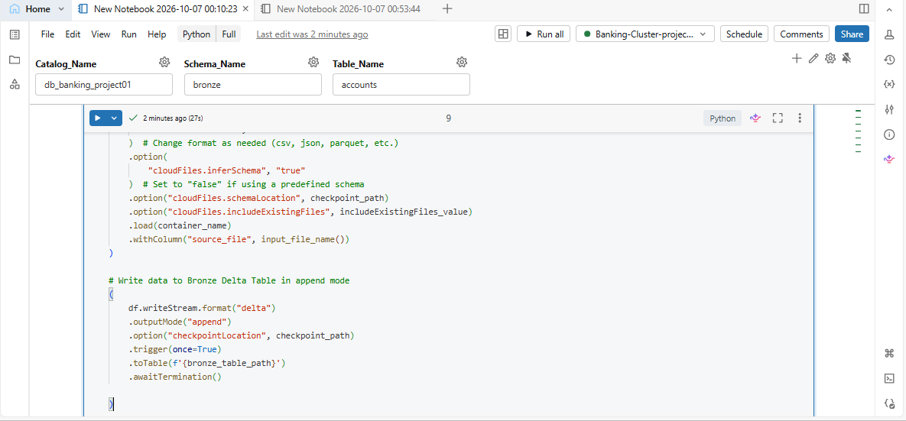

Finally we can see this table created in unity for as account table for account dataset.
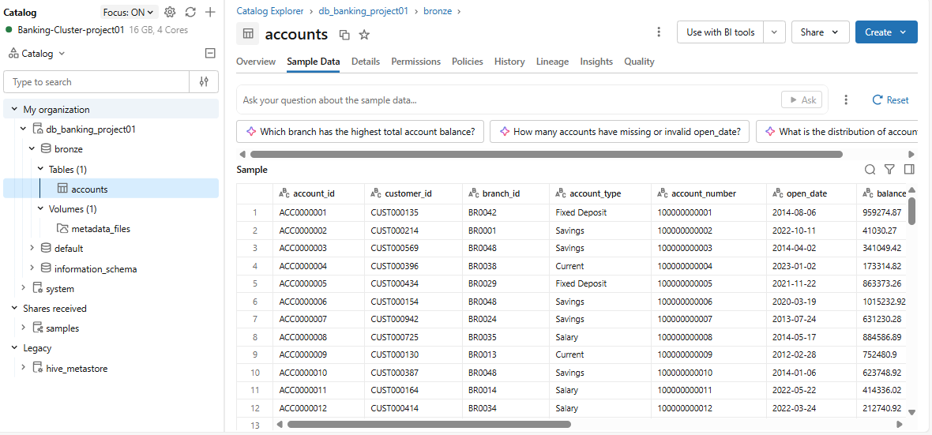

Project Completed

